except on a Wednesday and Friday afternoon at
Issue 4 – Autumn 2018 Final Issue

Patient Newsletter
Gorleston Medical Centre, Shrublands Health Centre, Magdalen Way, Gorleston Nr31 7BP Tel: 01493 650490
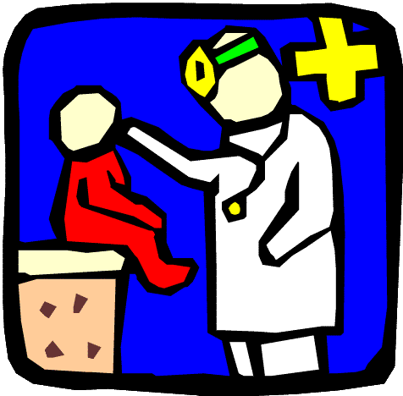
Hopton Surgery, Station Road, Hopton-on-Sea, NR31 9BE Tel: 01502 732246
Our website: www.gorlestonandhoptonsurgery.co.uk
Patient Participation Group (PPG) Your PPG is disbanding following the merger between Hopton Surgery, Gorleston Medical Centre and the Central Healthcare Centre. From October 1st, all 3 medical centres will be known as The Beaches Medical Centre. Your PPG has raised £1000 over a period of time, and the members Loretta, Karin, Jean and John (see picture) have decided each to donate £250 to a charity or cause of their choice to benefit local people. This is this PPG’s final newsletter.

Loretta, Karin, Jean, John
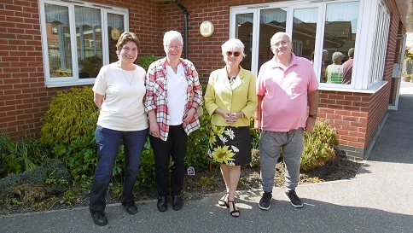
Loretta’s donation is to a small local charity called Care4Us. This is a support group for the carers of mental health patients. The group has been running for 8 years, was originally sponsored by MIND and is now self funding. They meet at the Louise Hamilton Centre on the last Wednesday of the month, from midday until 2pm. New members are welcome to join this friendly group. Karin’s cause is the BRAS group (BeReASsured), a group which helps and supports women and men who have been diagnosed with breast cancer. They are present in the waiting area at the breast clinic at the JPH, Broadland Suite, on a Wednesday afternoon. When required, they will speak to those women/men immediately after diagnosis. All members of the BRAS group have been diagnosed with breast cancer themselves at some point and are in a position to offer help and support. Occasionally they have fundraising events and once a year they run a "Pamper Day" to which all people affected by breast cancer and guests are invited. At the "Pamper Day", there are make-up and cooking demonstrations, health advice, cake sales and many other activities. Any money they raise will be spent on breast cancer patients' needs outside the responsibility of the NHS. Jean’s donation will be to the Friends of Old St Margarets- a group of volunteers and friends, led by Graham Mills, who maintain the gardens surrounding our beautiful medieval church ruins on the Coast Road in Hopton. Continuously working to keep the gardens in good order, the volunteers rely on donations to purchase additional tools and planting each year. There is a lovely memorial rose garden with a seated area nearby to sit and enjoy the display. A cherry tree, fig tree and 10 medieval species of apple trees will over the years hopefully bear fruit for visitors to enjoy. There are some lovely seating areas dotted around the garden to encourage people to stop a while and just absorb the peaceful, relaxed atmosphere. The gardens are open to any passers-by, 24 hours a day, 7 days a week and are there for all to enjoy. John would like a donation to go to Great Yarmouth and Gorleston Young Carers (GYGYC). This is a Gorleston based group which helps young people aged from 8 to 25, who have to look after a parent or sibling at home. This person may not be mobile, be long term sick or be incapacitated. The GYGYC offer opportunities for these young carers to chat, relax and build on their self–esteem and confidence so that they can discuss coping strategies and express their feelings, hopes and fears. This is to give them a break and also meet others who are in a similar position.
Booking an appointment online. You can now book an appointment online. We may share your information with others involved in your care or where the law requires information to be passed on.

Loretta, Jean, John and Karin would like to thank all patients who have supported the PPG in their activities, as well as all former members of the PPG – Alison, Martin, Shirl, Faith and Karen – who have worked very hard over the years for the patients of Hopton Surgery and Gorleston Medical Centre.

MERGER INFORMATION

The new name will be The Beaches Medical Centre
This Photo by Unknown Author is licensed under CC BY-SA
Date of merger: Monday 1st October 2018
When you phone the surgery, use the same phone number as you currently use. In the future, we will be changing the telephone system so you dial one number and then choose which branch you would like to speak to. This means you can make an appointment at whichever branch you require.

Internet access will remain the same but appointments will reflect all sites, so you can make appointments at any of the three sites: Sussex Road, Magdalen Way or Hopton.

What impact will the merger have on you, the patient? Very little, it’s just business as usual, but you will have more choice on where you can be seen.

Breaking News – FLU jabs! We now have our flu vaccinations in stock. Please make an appointment with the practice nurse to have your flu injection as soon as possible.

Booking an appointment online
You can now book an appointment online. Ask a receptionist how to do this. Please bring some photo ID and proof of address when enquiring. We also currently send out SMS text alerts reminding patients of their impending appointments. We may share your information with others involved in your care or where the law requires information to be passed on.

Our New System

Your contact information
Help us improve our communications by ensuring we have your up to date contact details, such as your home address and telephone number, together with your mobile number and personal email address. We currently send out SMS text alerts reminding patients of their impending appointments. Remember you can always book an appointment online. Ask a receptionist how to do this. Please bring some photo ID and proof of address when enquiring.

Our New System

Missed appointments… In April 2018 a total of 32 healthcare appointments in Hopton and 142 at Gorleston Medical Centre were wasted, appointments missed that you and other patients could have booked. This is an unacceptable level and easily avoidable if patients would remember to cancel unwanted appointments by calling the surgery. Your co-operation is greatly appreciated and will benefit others! We would also like to say a “big thank you” to patients who do attend their appointments or cancel in time for these appointments to be re-used by other patients.

