except on a Wednesday and Friday afternoon at
Issue 3 – Summer 2018
Patient Newsletter
Gorleston Medical Centre, Shrublands Health Centre, Magdalen Way, Gorleston Nr31 7BP Tel: 01493 650490
Hopton Surgery, Station Road, Hopton-on-Sea, NR31 9BE Tel: 01502 732246
Our website: www.gorlestonandhoptonsurgery.co.uk

25th May 2018 GDPR – New Regulations GDPR – New Regulations out today, the surgery would like to remind patients of the following. ‘We maintain our duty of confidentiality to you at all times. We will only ever use or pass on information about you if others involved in your care have a genuine need for it. We will not disclose your information to any third party without your permission unless there are exceptional circumstances (i.e life or death situations), or where the law requires information to be passed on.’

Booking an appointment online You can now book an appointment online. Ask a receptionist how to do this. Please bring some photo ID and proof of address when enquiring. We also currently send out SMS text alerts reminding patients of their impending appointments. Please inform us if do not wish to receive SMS message and confirm with reception if you are happy to receive SMS messages

Our New System

Breaking News
Gorleston Medical Centre and Hopton Surgery are pleased to announce that 2 new doctors have been appointed. They are Dr Maleki and Dr O’Donnell. Leigh, our healthcare assistant has gone on maternity leave. We wish her well.
Jess, our new phlebotomist is working 5 mornings a week.

Thank you again to all those patients and staff who donated so generously to the food banks at Gorleston Medical Centre and Hopton Surgery. It is very much appreciated. (Photo taken by JohnTonks)

Thank you very much!
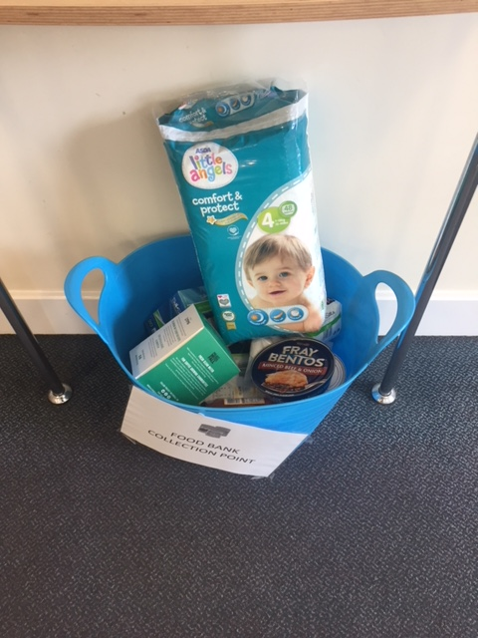

Your PPG members are (from left to right): Loretta, Karin, Jean and John
Loretta, Karin, Jean, John

Meet the members of your Patient Participation Group (PPG)
Gorleston Medical Centre and Hopton Surgery have an active Patient Participation Group (PPG) – now virtual
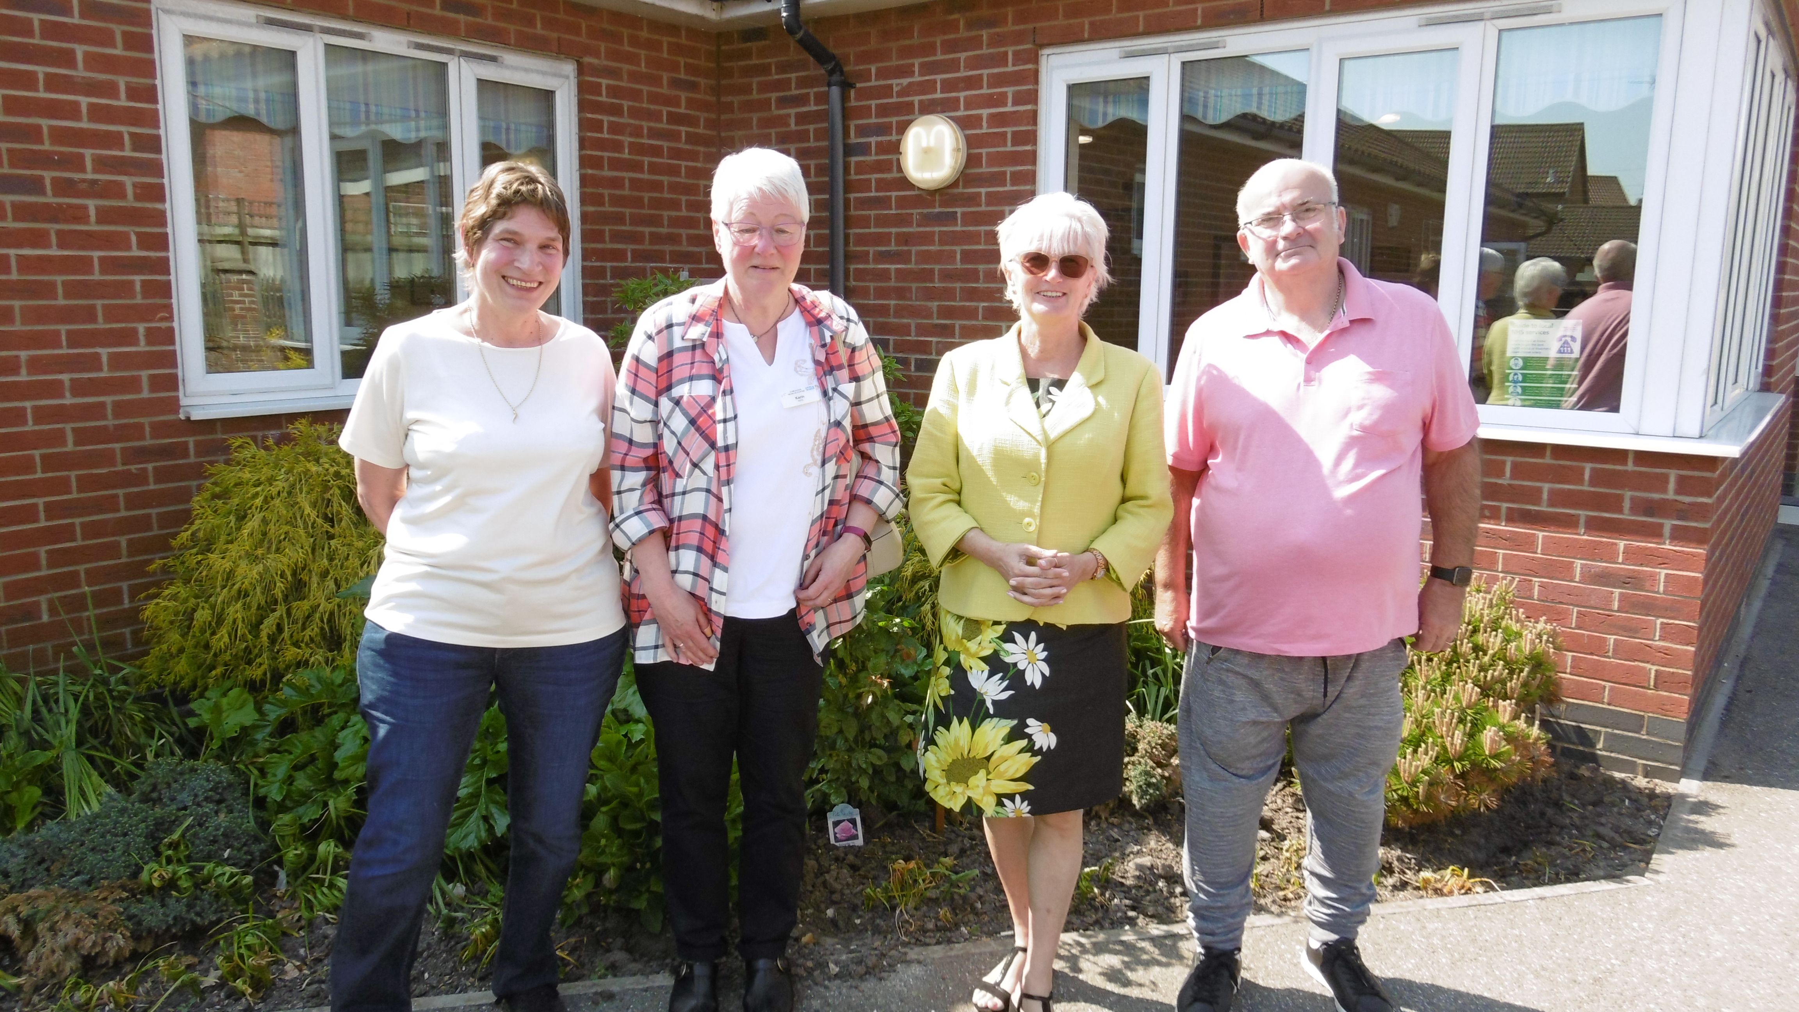

Who are the members ? People who are patients at either surgery and would like to have a say in what improvements can be made for patients.
What do we do? We e-mail each other regularly to discuss matters arising from and for patients. Occasionally we raise funds, meet or organise coffee mornings. We also maintain notice boards in both surgeries.
Where are the meetings? At either Hopton Surgery or Gorleston Medical Centre.
Who can join? Any patient who is interested in having a direct involvement in the services and running of the practice.
How can people join? Visit the website www.gorlestonandhoptonsurgery.co.uk and follow the links. Alternatively, you can contact the practice manager, speak to a member of the reception team directly or email us on gorlestonandhoptonppg@gmail.com

Making an appointment…Appointments can be made by telephone or in person during our above opening times. You can also make an appointment online (ask at reception for more details). Consultations are 10 minutes in duration. Clinical sessions are each morning and each afternoon; late morning/lunchtime sessions are usually reserved for telephone consultation and home visits.
Where is my doctor? (June)
Dr Ranjeet Verma (m) (MRCP) Gorleston Medical Centre Thursday pm, Friday pm (LN) Hopton Surgery
Thursday am, Friday am
Dr Sunder Gopaul (m) M.R.C.S. M.R.C.S.I M.R.C.G.P.
Gorleston Medical Centre
Monday/Wednesday/Friday am and pm
Hopton Surgery
Tuesday pm
Dr Johanne Adly (f)
Gorleston Medical Centre
Monday pm, Tuesday am, Wednesday and Thursday am and pm
Hopton Surgery
Monday and Tuesday am
Dr Maleki (m)
Gorleston Medical Centre
Tuesday am and pm, Wednesday pm
Hopton Surgery
Wednesday am
Dr O’Donnell (m)
Gorleston Medical Centre
Monday and Thursday am
Tuesday and Friday am and pm
Hopton Surgery
Monday and Thursday pm

Missed appointments… In April 2018 a total of 32 healthcare appointments in Hopton and 142 at Gorleston Medical Centre were wasted, appointments missed that you and other patients could have booked. This is an unacceptable level and easily avoidable if patients would remember to cancel unwanted appointments by calling the surgery. Your co-operation is greatly appreciated and will benefit others! We would also like to say a “big thank you” to patients who do attend their appointments or cancel in time for these appointments to be re-used by other patients.
Alternative location…If a suitable appointment is unavailable at your regular surgery, remember, your registration entitles you to visit either GMC or Hopton locations. The receptionist should inform you that your first appointment choice is unavailable but capacity exists at another location. Please remember to enquire.
Speaking to a clinician…If you wish to speak to a clinician over the telephone, please call the surgery after 10am and give a brief explanation to the receptionist as to the nature of your call. You will be asked for a contact number and will be given a rough guide as to when the clinician might return your call. This information is then added to the GP’s clinic in telephone call slots. Please note this is an estimate time only and is subject to change or cancellation should the clinician be called away on an emergency. Alternatively, you will be given a time as to when to call the surgery again.
Repeat Prescriptions…. Please remember we do not take repeat prescription requests over the telephone unless you are a housebound patient. Please remember when ordering prescriptions to try and use your green repeat slip. Ask about EPS (electronic prescribing) if you do not already have your repeats sent to a chemist of your choice.
Visit our website: www.gorlestonandhoptonsurgery.co.uk
Our website is packed with useful information about the services we offer, opening times, how to access our services, the GPs and staff who work here. It also contains essential advice about a variety of common medical conditions, as well as video clips from experts. You can also submit your repeat prescription requests online. So why not give it a go and tell us what you think. We are always looking for patient feedback on how we can improve.

Meet a member of your Healthcare Team Ann is the practice nurse and has worked in Gorleston Medical Centre and Hopton Surgery for 9 years. She deals with chronic disease management of Diabetes, Asthma and COPD, including performing spirometry. Ann also assists Dr Gopaul in minor operations. She is very interested in contraception and sexual health and runs the cervical recall screening for the surgeries. Ann also administers childhood vaccinations and runs a Baby immunisation Clinic. She advises on travel health and vaccinations required for travelling abroad. Ann performs ECG’s, blood tests, blood pressure checks, ear irrigation, and minor illness care. Ann also supports patients who wish to stop smoking. In her spare time she loves to go sailing and swimming and recently qualified as an advanced scuba diver.

Please remember: The NHS operates a policy of Zero Tolerance against threatening and abusive behaviour to all NHS staff and the surgery will act upon this policy if necessary.

